5th Aboriginal Math K-12 Symposium: Sharing Approaches for
Improving Aboriginal Mathematics Education

February 27, 2015, 9:00 am - 3:15 pm.
UBC First Nations Longhouse (1985 West Mall)

Please join us for the 5th Aboriginal Math K-12 Symposium at the First Nations Longhouse, UBC on February 27, 2015. This symposium is an opportunity for teachers, administrators, Ministry representatives, community members, and academics to connect, explore, imagine and share new ideas, resources and research on Aboriginal mathematics education from kindergarten to Grade 12. Together we hope to:
- Learn about new research in mathematics and Aboriginal education
- Discuss and share approaches, research and educational projects for improving Aboriginal math education
- Develop community connections to facilitate and support improving Aboriginal math education

Program Description
During the day we will work on activities that involve the connections of mathematics, students, and community. Participants will have opportunities to do mathematics, explore cultural connections, network with others, share stories, and discuss and share their research and teaching strategies with each other.

Agenda: 8:45 am – 3:00 pm
8:45 – 9:00 am Pick up registration material. Coffee/Tea available. Meet & Greet.
9:00 – 9:35 am Welcoming Remarks and Story
Coming Together with Mathematics; Getting to Know Your Neighbours
9:35 – 10:10 am Story, Drawing, and Mathematics with Haida Artist Billy Yovanovich, Haida Gwaii
10:10 – 11:25 am Bringing Math to the Community; Doing Math with the Community
10:45 – 11:15 am Refreshment Break
11:25 – 12:20 am Informal Sharing (participants sharing ideas and projects – 10 min each)
12:20 – 1:00 pm. Lunch is provided
1:00 – 1:45 pm Informal Sharing Projects (participants sharing ideas and projects – 10 min each)
1:45 – 2:15 pm Story, Community and Math with Raven Brings the Light
2:15 – 2:45pm A Conversation with Niakapamux Artist Andrew Dexel Enpaauk.
2:45 – 3:15 pm Wrap-up Discussion, Door Prizes.

For questions, please contact: indigenous.education@ubc.ca
Registration closes February 24, 2015. Registration fees: $25: http://tinyurl.com/5thAboriginalMathSymposium

Hosts: Jo-ann Archibald, Cynthia Nicol – UBC Faculty of Education; & Melania Alvarez, PIMS
Sponsors: Indigenous Education Institute of Canada-UBC Faculty of Education; Pacific Institute for the Mathematical Sciences (PIMS); Department of Curriculum and Pedagogy UBC; UBC Indigenous Teacher Education Program (NITEP); The Actuarial Foundation of Canada.
Featuring
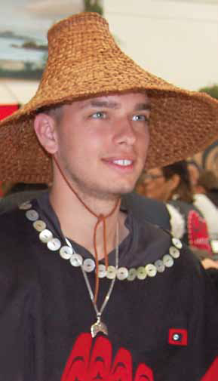
Billy Yovanovich, Haida Artist

Artist William (Billy) NC Yovanovich Jr.––whose Haida name is Kuuhlanuu––is a member of the Ts’aahl Eagle Clan of Skidegate, Haida Gwaii. Billy is a recent graduate of Queen Charlotte Secondary School in Skidegate and has studied Haida art under well-known Haida artist Robert Davidson. Inspiration for Billy’s Haida designs come from Haida legends and stories, and the spectacular land and sea that make up Haida Gwaii.

Billy returns to this year’s Symposium by popular demand.

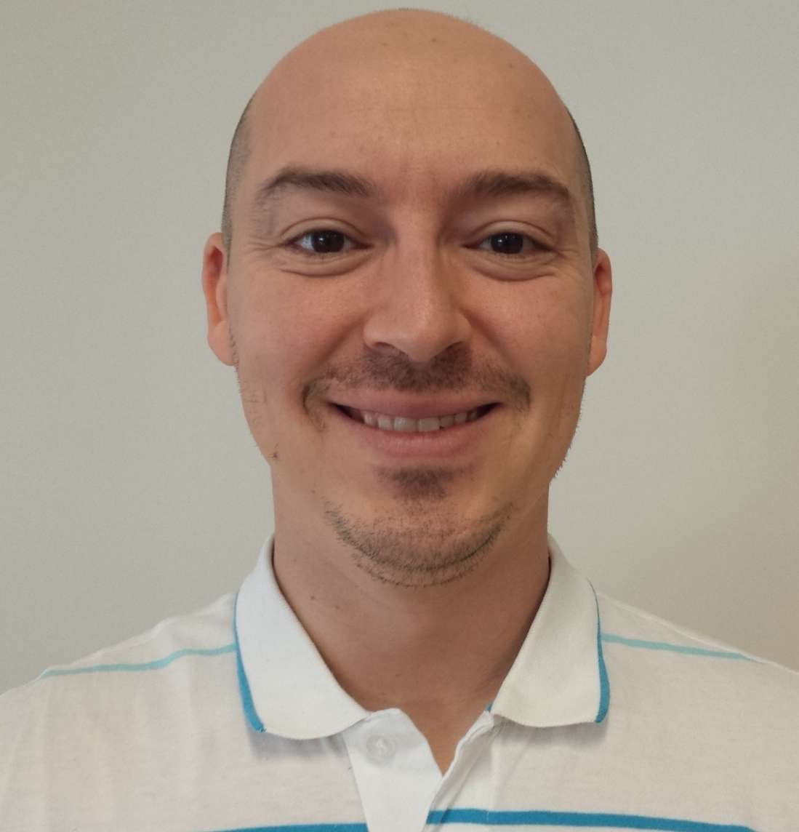
Shawn Desauliners, PhD, UBC Mathematics Department
Shawn is a faculty member of the Department of Mathematics at UBC. He is an instructor and also serves as an Aboriginal Outreach Coordinator for the Faculty of Science. He is Metis Canadian and has a PhD in mathematics from the University of Alberta. Shawn will attend this year with his MATH 335 NITEP students to offer us intriguing math problems that can bring math, students and the community together.

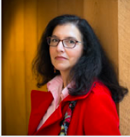
Melania Alvarez UBC Mathematics Department and PIMS
Melania is UBC’s Mathematics Outreach Coordinator and the BC Education Coordinator for the Pacific Institute for the Mathematical Sciences (PIMS). Melania is currently teaching a section of MATH 335 at UBC and, along with Shawn Desaulniers, brings her students to this year’s Symposium to offer us math problems you can’t refuse.

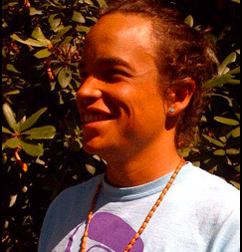
Enpaauk Andrew Dexel, Niakapamux Artist
Andrew is a print artist from the Niakapamux Nation who began as a graffiti artist and now paints on canvas. His work has been featured in galleries in Vancouver, Seattle, Ottawa, Kamloops, and Honolulu and published in magazines such as Redwire, Blood Lines and Brunt. Andrew will share some of his work and engage in a conversation around its connections to mathematics.

Informal Sharing Contributors (confirmed)

Shawn Desaulniers, UBC | Jennifer Sherif, Aboriginal Education Enhancement, VSB
Anjeanette Dawson, Squamish Nation (wool weaving) | Nathalie Sinclair, Simon Fraser University
Caitlin Johnston, Vancouver Island University | Joanne Yovanovich, School District 50 Haida Gwaii
David Sufrin, Vancouver Island University

